|  |  |
| --- | --- |
| Test Name | UC02 Swipe Borrow Card |
| Use Case Tested: | Swipe Borrow Card |
| Test Description: | Allows the user to swipe their borrowing card and commence scanning of books. |
| Pre-conditions | The program has been started and initialised.  The “Borrow” button has been pressed.  The “Swipe” panel is active. |
| Post-conditions | **Member exists and not restricted**  The system enables the “Scanning” panel.  The Complete and Cancel buttons are enabled.  The Borrower card panel is disabled.  The Book scanner is enabled.  Borrower details are displayed.  Existing loans are displayed.  Existing fine message displayed if relevant.  **Member exists and restricted**  The system enables the “Restricted” panel.  The Cancel button is enabled.  The Borrower card panel is disabled.  The Book scanner is disabled.  Borrower details are displayed.  Existing loans are displayed.  Existing fine message displayed if relevant.  Overdue message displayed if relevant.  At loan limit message displayed if relevant.  Borrowing restricted error message displayed. |
| Notes: |  |

|  |  |
| --- | --- |
| Data 1 Attempt – NOT RESTRICTED |  |
| Result (Pass/Fail/Warning/Incomplete) | Pass |

|  |  |  |  |  |
| --- | --- | --- | --- | --- |
|  | TEST STEP | EXPECTED TEST RESULTS | P | F |
|  | Borrower scans their card or enters their number and presses “Swipe Card” | The system enables the “Scanning” panel. | P |  |
|  |  | The Complete and Cancel buttons are enabled. | P |  |
|  |  | The Borrower card panel is disabled. | P |  |
|  |  | The Book scanner is enabled. | P |  |
|  |  | Borrower details are displayed. | P |  |
|  |  | Existing loans are displayed. | P |  |
|  |  | Existing fine message displayed if relevant. | P |  |

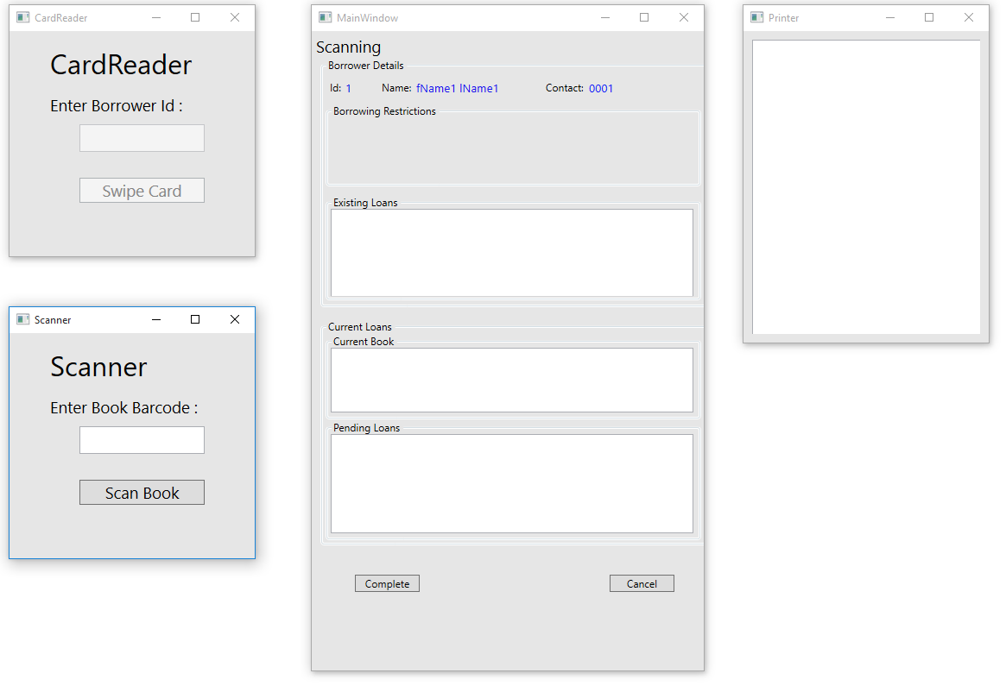

|  |  |
| --- | --- |
| Data 2 Attempt – RESTRICTED |  |
| Result (Pass/Fail/Warning/Incomplete) | Fail |

|  |  |  |  |  |
| --- | --- | --- | --- | --- |
|  | TEST STEP | EXPECTED TEST RESULTS | P | F |
|  | Borrower scans their card or enters their number and presses “Swipe Card” | The system enables the “Restricted” panel. | P |  |
|  |  | The Cancel button is enabled. | P |  |
|  |  | The Borrower card panel is disabled. | P |  |
|  |  | The Book scanner is disabled. | P |  |
|  |  | Borrower details are displayed. | P |  |
|  |  | Existing loans are displayed. |  | F |
|  |  | Existing fine message displayed if relevant. | P |  |
|  |  | Overdue message displayed if relevant. | P |  |
|  |  | At loan limit message displayed if relevant. | P |  |
|  |  | Borrowing restricted error message displayed. | P |  |

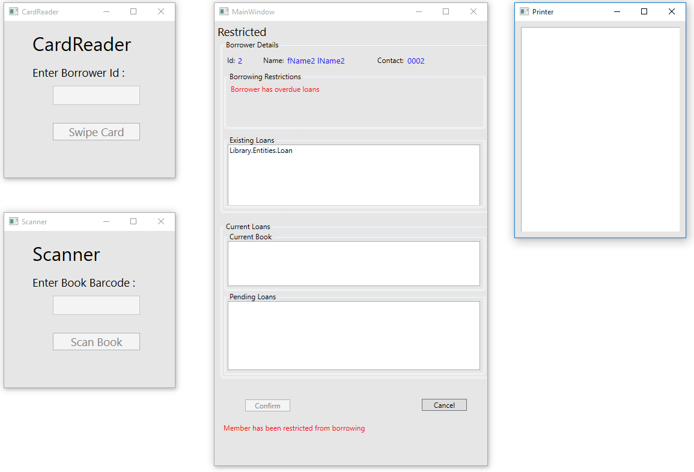

|  |  |  |  |  |  |
| --- | --- | --- | --- | --- | --- |
| Test Data Table | | | | | |
|  | **1** | **2** | **3** | **4** | **5** |
| Data 1 Attempt | 1 |  |  |  |  |
| Data 2 Attempt | 2 |  |  |  |  |
| [Data field 3] | [data set 1 input value for field 3] |  |  |  |  |